**FUNCTIONAL DECOMPOSITION DIAGRAM**

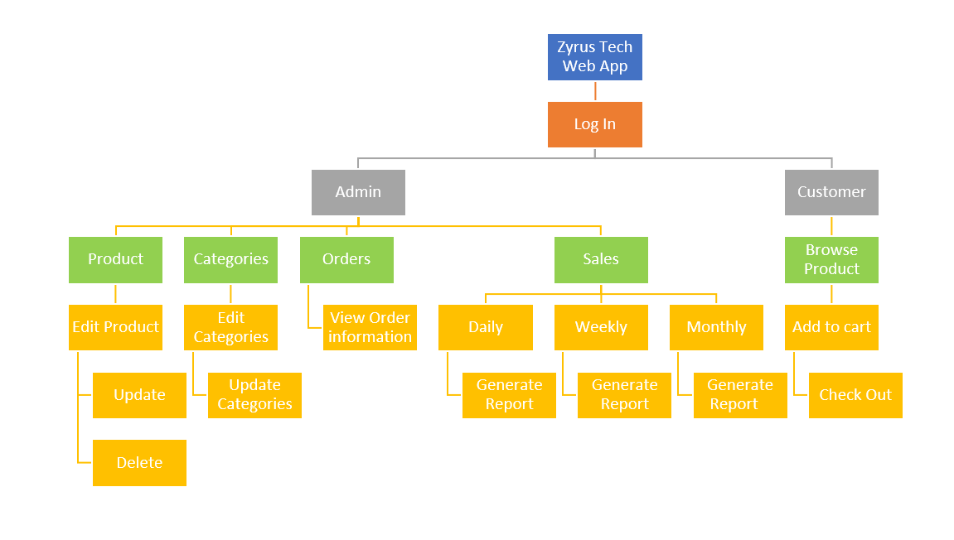

*Figure 3.2 FUNCTIONAL DECOMPOSITION DIAGRAM of Zyrus Tech Web App*